# Regrowth

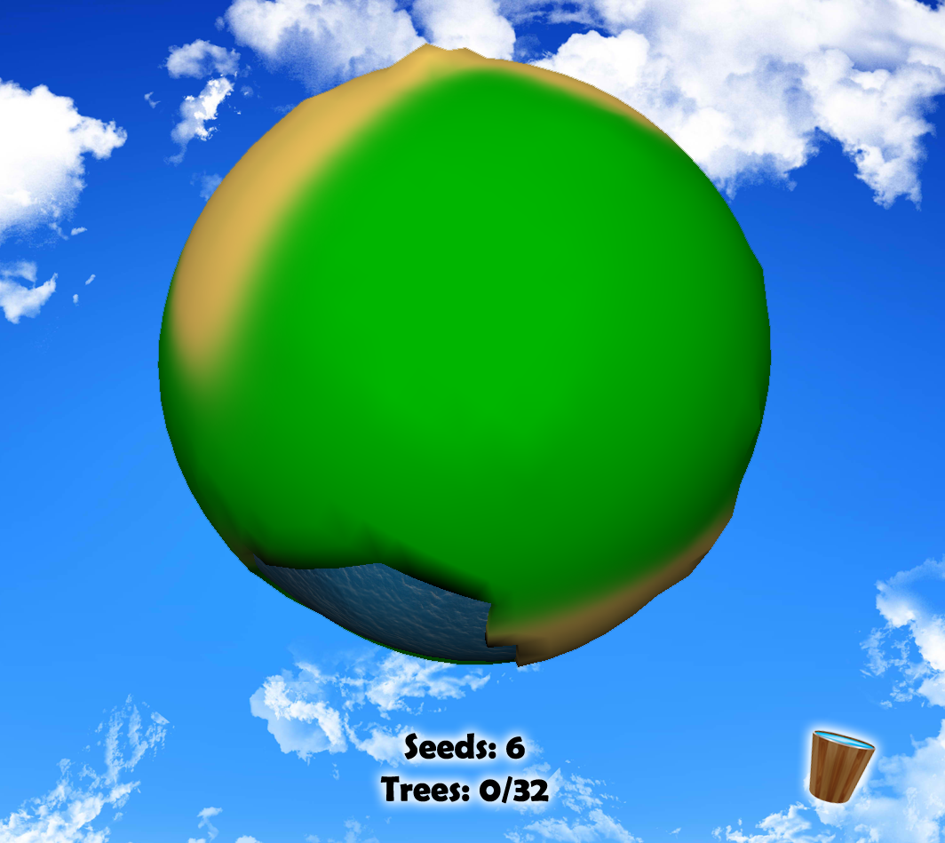

### Benjamin Lovegrove GDS210

### 1000958

# *A fast paced take on an ecosystem sim which aims to revegetate a mini planet.*

# Basis

## Concept

The player is tasked with re-vegetating a small planet that has become barren and covered in vine weeds. This is achieved by planting trees that grow over time and are the victim of a harsh environment. As the planet becomes more densely vegetated outbreaks of fire and weeds will become more catastrophic and harder to deal with.

The level is completed when a set amount of trees based on planet size have fully grown. On average this should take 2-3 minutes for this level.

## Platform

The target platform for Regrowth as a 2-3 minute game is web with high potential to also be ported as a mobile game (touch screen friendly with swiping for movement and playable with a single button (touch)).

## Audiences

Regrowth will be primarily targeted to:

Casual audiences

* Short minimum game time
* Simple gameplay
* Web/Mobile
* Bright appealing graphics

Gamers

* Short minimum game time (“downtime” game)
* Fast paced and challenging aspects with potential to master (planting patterns, respawn timers etc.)
* Potential to compare tactics and completion times with friends

Simulation game fans

* Strong sim aspects for a “quick fix”. See your plants grow.
* Strong potential for further development into additional sim mechanics/ongoing planets/seasons/etc.

# Core mechanics

## Revegetation

Completely rejuvenating the planet is the main focus of the game and is achieved in three stages.

# Seed - Sproutling - Tree

The player starts with a set amount of seeds and obtains more by digging up vine weeds. These are then placed on the planet’s surface with left click and instantly turn into a sprout. Sprouts then take a random amount of time between x and y to turn into a full tree. Seeds cannot be planted within a certain range of other trees or sproutlings.

## Vine weeds

Vine weeds are the first encountered environmental antagonist and exist throughout the game. There are set spawn points all over the planet and they are all spawned when the game starts. Vine weeds are then removed with right click and may produce a tree seed. After removal a random respawn timer between x and y is set.

When vine weeds spawn within x distance of trees the trees will start to die displayed with a different tree model. The vine weed must be removed within x seconds or the trees will disappear.

Vine weeds will be a small clumping on vines that take around the same space as a base of a tree.

## Fires

Fire’s only affect fully grown trees on a very low % chance per update so they will be rare at the beginning of the game. Each tree added will have the same chance to ignite so towards the end of the game the risk will vastly ramp up. Also as the trees will be more densely planted there will be more of a chance of loss due to spreading and it will be harder to combat.

When a fire starts there will be a fire system on the afflicted tree and the tree will change to the “dying” model. Trees within a certain range will also instantly be ignited. To extinguish a fire the player must first obtain water by pressing space while hovering the mouse over a water source. When the player has water pressing space while hovering over a fire will extinguish that single tree. This means that for a multi tree fire the player will have to repeatedly go between the water source and the fire.

Trees will become invulnerable to fire for x amount of seconds after being extinguished to avoid instant re-ignition. In the event that it is not possible to put out all of the fires before trees begin to re-ignite the player will have to sacrifice some of the trees.

## Controls

### Mouse 1 *Plant seed*

### Mouse 2 *Remove Vine Weed*

### Space *Gather water, Extinguish fire*

### WASD *Rotate camera around planet*

# Aesthetic

### Art Theme

The theme will be bright and vivid with strong blue and green aspects. Detail/polys will be minimum. Modern “Cartoonish” effect. Below image is reference examples only.

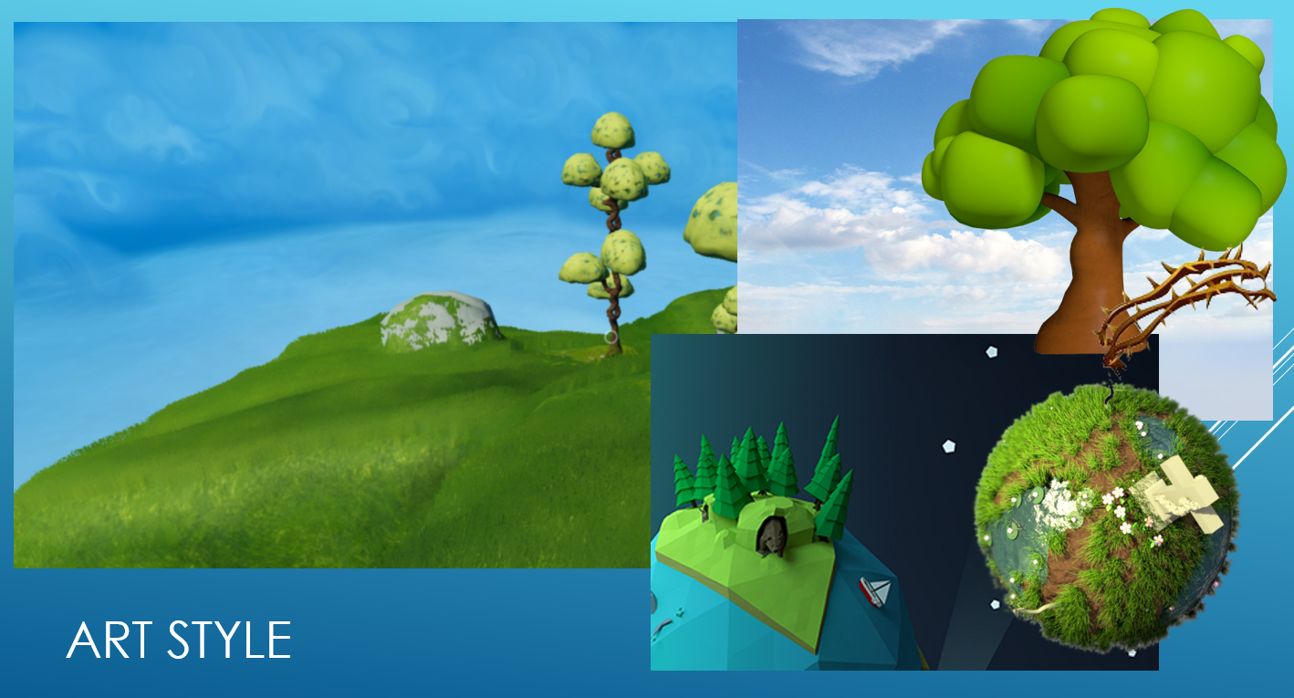

### UI

The UI should be very minimalist to remain consistent with the simplistic mechanics, target audiences/platforms and art theme. Refer to front page for UI concept.

The minimum required information is:

* Player seed count
* Target and current tree count
* If the player has water